April 2020

Dear Parent / Carer

Given most young people will be using their computers and ‘phones at an increased rate during the academy closure we are sending a few ideas and key messages about Online Safety.

‘Think U Know’ will be publishing activities you can complete with your child at home every two weeks to promote online safety. These can be found [here](https://www.thinkuknow.co.uk/parents/support-tools/home-activity-worksheets?utm_source=Thinkuknow&utm_campaign=03cb8440df-TUK_ONLINE_SAFETY_AT_HOME_24_03_20&utm_medium=email&utm_term=0_0b54505554-03cb8440df-55227753). We would encourage parents and carers to look at these with your child if possible. Now might also be a good time to recap the SMART rules of staying safe online that we encourage our students to follow:

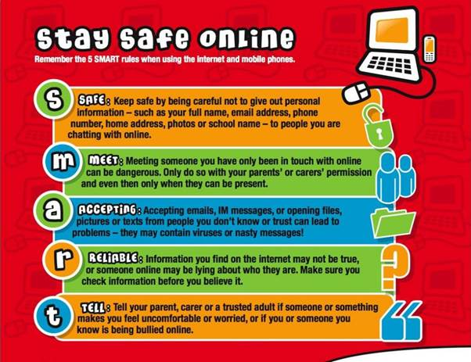

‘Think U Know’ have also published some excellent advice on keeping children safe during this time. Please see below:

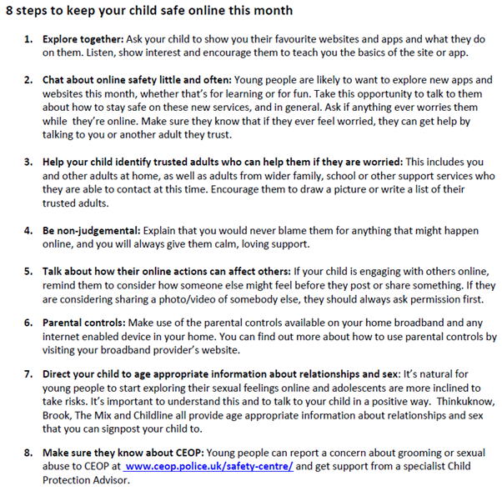

Finally, please be wary that unfortunately people are using the coronavirus to take advantage of people with hacking, phishing and other scams. Examples can be found in a BBC article [here](https://www.bbc.co.uk/news/technology-51838468). We strongly advise people to be vigilant with any communications received.

Yours faithfully

Mr S Liu