Y8 to 9 Guided Selections

Dear Parent/Carer

In order to move forward with the appropriate curriculum for your child we are developing the ‘guided selection’ process for Year 9. We will work towards ensuring the correct curriculum for every student.

In Year 9 all students will study English, mathematics, science, world views, physical education, history, geography and French. There will be two further subject curriculum areas to select from. They will be from either technology (computer science, food or design technology) or the arts (art, music or drama). This will add breadth to the Year 9 curriculum and also help with future decisions with Years 10 and 11 selections. The choices you make in Year 9 we would envisage carrying forward into Year 10 and 11. However, we do allow students to change for specific reasons.

We foresee that a small number of students will require a more personalised curriculum which allows for extra English and mathematics. This will be brokered on an individual basis.

If, at this stage, your child has a career or further education ambition please let us know to help with this and any careers guidance we may offer.

Please be aware that due to constraints with staffing and timetables that on some occasion’s students may not receive both their first and second choice. We therefore ask you to put a reserve subject down in the unfortunate event we cannot satisfy every student. You will be informed on their guided selection allocation in June/July when the timetables are written.

In a years’ time we will be making Year 10 (GCSE and other level 2 course) subject choices for their Key Stage 4 curriculum.

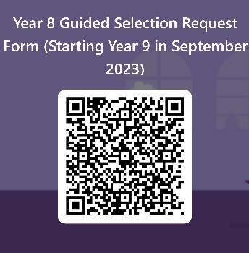

https://forms.office.com/e/BXW9hwnJGF

Please complete the forms quiz using the link or QR code above by Friday 24th March 2023.

If you have any further questions please don’t hesitate to contact myself, Mr Moss (Head of Year) or your child’s form tutor. Parents evening for Year 8 is on Thursday 9th March and staff will be available to discuss guided selections further.

Kind regards

Mrs Hickin
Assistant Headteacher (Curriculum and Quality Assurance)

